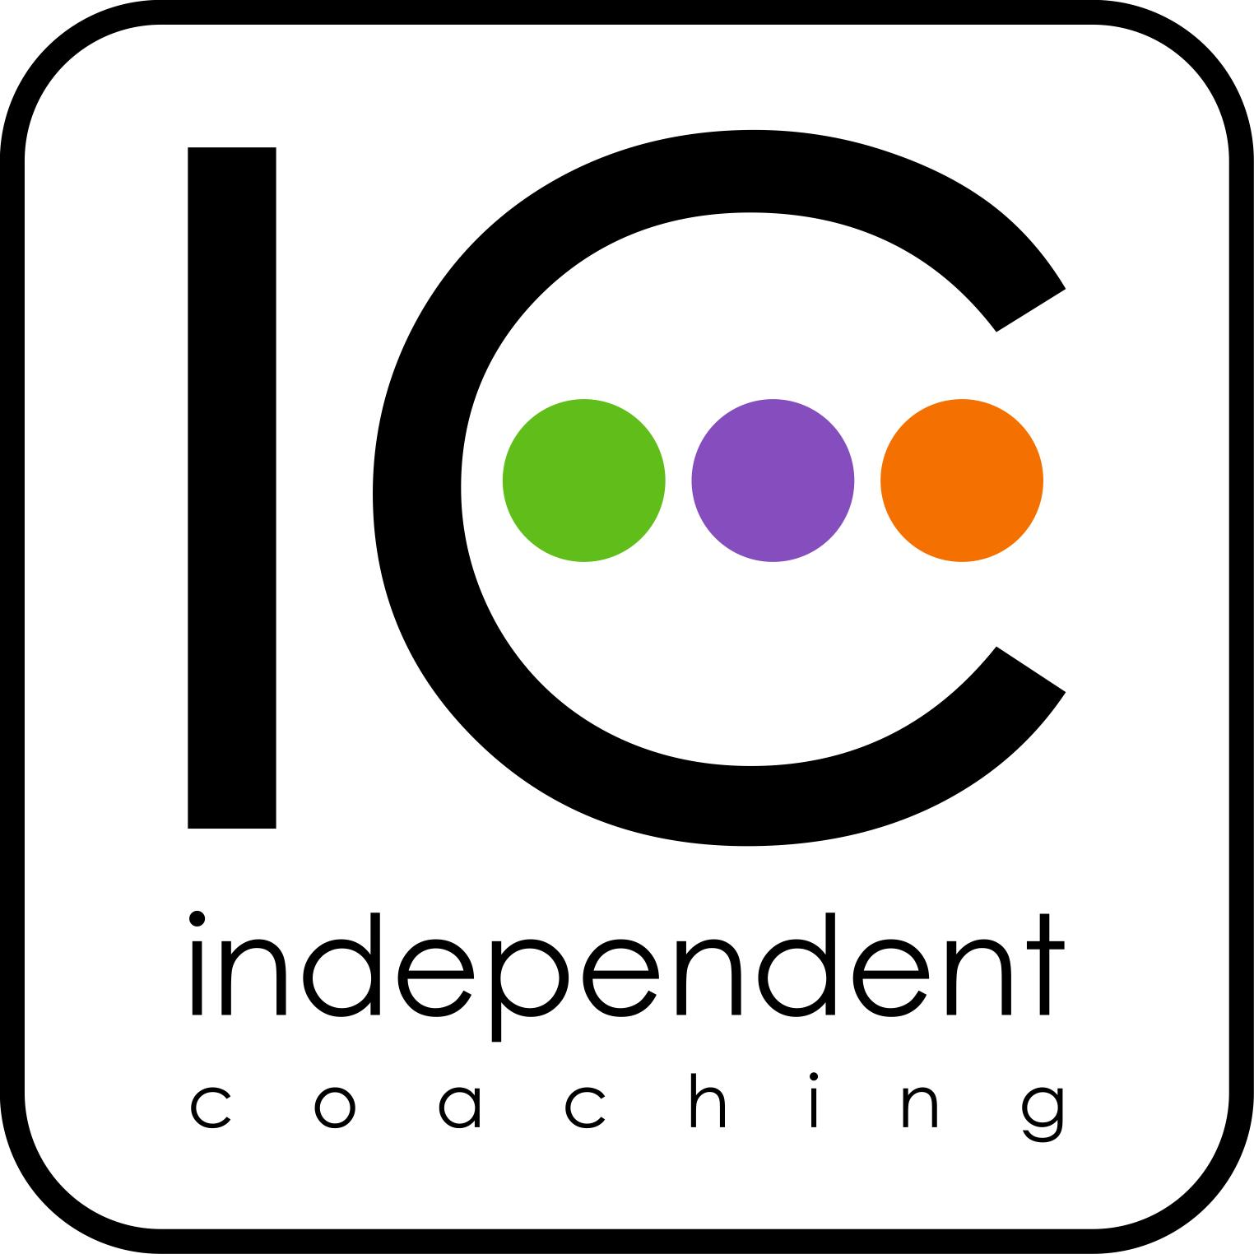
The Leadership Coaching Skills Programme ~ overview

The Leadership Coaching Skills (LCS) Programme is for leaders in education, serious about developing their own leadership potential and that of others. With the phenomenal complexity and rate of change experienced by most organisations at the moment, leadership has become the single most important master skill for success. And such leadership needs to attend to the very particular human mix and wonder within each organisation ~ people and their real potential. Leadership skills are essential for developing organisational wellbeing and performance.

In one sense we all know this. What the programme does is to help us learn very specifically how we do this. The potential for organisations when the core leadership all begin to work with similar knowledge and understanding is immense.

The key is relationships: ‘school improvement is technically quite simple but socially complex’ (Ainscow, 2015). Individual, team and school performance is as much about our relationships and emotional intelligence as it is about our knowledge and skills. And more broadly, education at all levels is about humanity, the heart and the emotions as well as the intellect.

The programme is about leadership learning through personal growth and professional practice. We are fundamentally working with human potential, rather than human frailties and deficiencies, working with learning rather than judgements. Accountability for learning is with you and those you work with on the programme. It is what you know that will make the difference, what sense you make of learning, how you apply it to your own work, how you help others to grow, learn and develop. Accountability ultimately is through the quality of your work. You will speak through your own practice.

Rather than teach about leadership, the Programme develops actual leadership skills and capability, which you can use the next day at work.

By the end of the programme you will understand:
- how leadership coaching can accelerate professional learning;
- how leadership coaching can help find a way through issues and challenges which at first seem insurmountable; and
- how we can develop new insights and approaches to our own work and how we can help others to do the same.

The full course involves three programmes focusing progressively on the person, the organisation and the culture. Each programme provides three days intensive skills training with peer coaching follow-up. You will learn through tutor modelling and observation, through first-hand experience of working with a coach and through guided and carefully structured skills development in small groups.

Part 1 Personal leadership: awareness and responsibility
~ “Know thyself” Socrates

Coaching at this level aims at personal empowerment: the expansion of freedom of choice and action to shape one’s life and work. Something that needs saying, although uncomfortable, is that we all need our own sense of personal awareness and responsibility to help guard against the sometimes heavy waves of cynicism which can erode our values and convictions for education and learning.

The programme focuses on specific outcomes in terms of your skills, knowledge and understanding:
- being able to work with a range of coaching styles and approaches for different purposes;
- understanding the place of emotional intelligence in the human interactions and processes of the workplace;
- being able to improve such processes;
- being able to help with the performance, learning and development of others;
- being able to apply highly-developed skills of listening, attending, enabling and challenging; and
- developing professional reflection, learning and enquiry.

Themes
Ideal and creativity
Emotion and intelligence
Action and responsibility
Self-leadership
Coaching as action-learning
Emotional intelligence in the workplace
Coaching for work/life balance
Reflection

The nature of influence
The landscape of coaching
Coaching principles and purposes
Coaching roles and styles
The taboo of help
Listening, real listening
Structuring conversations
Reality and awareness

Part 2 Organisational leadership: performance and accountability ~ “We are social” (Dalai Lama)

In Part 2 the leadership coaching develops from the person-centred coaching of Part 1 towards the more pressing demands and imperatives of the workplace. This involves working with the wider school system, with teams and all the human and social dynamics, which are necessarily part of this broader picture. The nature of synergy and collaboration, motivation and engagement are all key features of this work, as is the question what does this ask of us as leaders?

Part 2 focuses on the skills, knowledge and understanding for:
- establishing sound contracting arrangements appropriate to context and purpose;
- coaching in a leadership role for learning, performance and accountability;
- attending to the ethics and boundaries of coaching;
- reflecting on and critiquing your own coaching practice; and
- contributing to team and organisational learning in this field.

Themes
The personal journey
Co-active coaching
Contracting, ethics and boundaries
Emotion and performance
Values
Coaching and school improvement
Opening up practice to scrutiny by peers
Reflective practice

Leadership as a social function
Self, service and others
Soft systems dynamics and analysis
The nature of tensions and barriers
Empowering leadership
Relationships: an organising principle
Leadership as a sense of self
De-centring from the ego

Part 3 Strategic leadership: coaching and culture
~ “The full flowering of human potential” (UNESCO)

Previously the programme has explored person-centred coaching and then working with the social systems, dynamics and relationships of the organisation. This third part moves us on to the key question: given this complexity and diversity of the school as a social system, how do we hold it all together?

Coaching at this third level works with the enigma and power of culture. The roots of performance and the roots of wellbeing are in the culture of the organisation. To raise performance do we work harder, work longer hours? Do we look to innovation and creativity? Do we look to collaborative ways of working?

Do we look to others to tell us what to do? And to what extent do we sacrifice wellbeing to performance goals and targets? Culture determines such ethics and norms.

How leaders understand and work with culture is a powerful influence on both performance and wellbeing. In this realm of leadership, what kind of a leader do we need to be? What kind of skills do we need?

Part 3 focuses on the skills, knowledge and understanding for:
- energising organisational culture and learning;
- working with the ethics of performance;
- stimulating reflective practice and enquiry;
- nurturing group and team communication; and
- improving network capability.

Themes
Cognitive ease, cognitive strain
Resistance
Integration and integrity
The head and heart at work
Intuition and risk
Presence and voice
Reflective practice, reading and enquiry

The organisation as whole
The nature of culture
The ethics of wellbeing
Social capital
Courage and compassion
Central coherence
The self as whole
Life stages and development

Coaching Partners

Coaching Partners is central to the development throughout the programme of personal learning, skills and confidence. It asks you, with a coaching partner, to commit to:

- Coaching: pairing up with a coaching partner or forming a small coaching group to practise coaching, feedback and reflection, with sessions arranged typically once or twice every half term.

- Reflective Learning: starting a learning journal to step back, reflect, develop self awareness and social awareness as a leader, and formulate goals.

- Reading and enquiry: broadening horizons, exploring, discussing, fostering personal curiosity and professional learning.

The most important reason to join Coaching Partners is that you then have your own personal coach. On-line tutor support is available throughout Coaching Partners.

Programme impact: what differences have programme participants seen in themselves and in the teams they work with?

- “Increased professional conversations in the classroom.”

- “More staff on board to manage change.”

- “Increased self-awareness and more positive attitude to school policy and teamwork.”

- People “trust to come to me. Attitudes to challenges have become more positive.”

- “More willingness to contribute without needing to be told what to do.”

- “Relationships are much more positive as trust and mutual respect are built.”

- “Staff meetings led in a more open manner.”

- “A calmer and more ‘effortlessly professional’ approach to managing personnel and workload – better relationships.”

- “More emotionally resilient and able to slow down and make more effective decisions.”

- “People are more open to talk about issues that lead to an end result rather than just talk about it in the staff room where the issues just escalate.”

- “The levels of trust and honesty have increased dramatically.”

Dr Paul Simmons, FRSA
Director, Independent Coaching

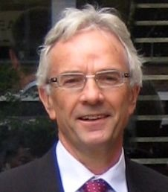
Paul is an experienced Executive Coach and member of the European Mentoring and Coaching Council (EMCC). Over a number of years at the University of Manchester, he led on the research and development of coaching for leaders in education. He has taught on Masters and Doctoral programmes. Most of his work now is with schools and colleges, helping to develop coaching expertise and culture. Paul has worked as a teacher, governor, examiner, County Advisor and Registered Inspector of Schools.

Contact

